**Computer Communication and Networks**

**Chapter 3 Problems**

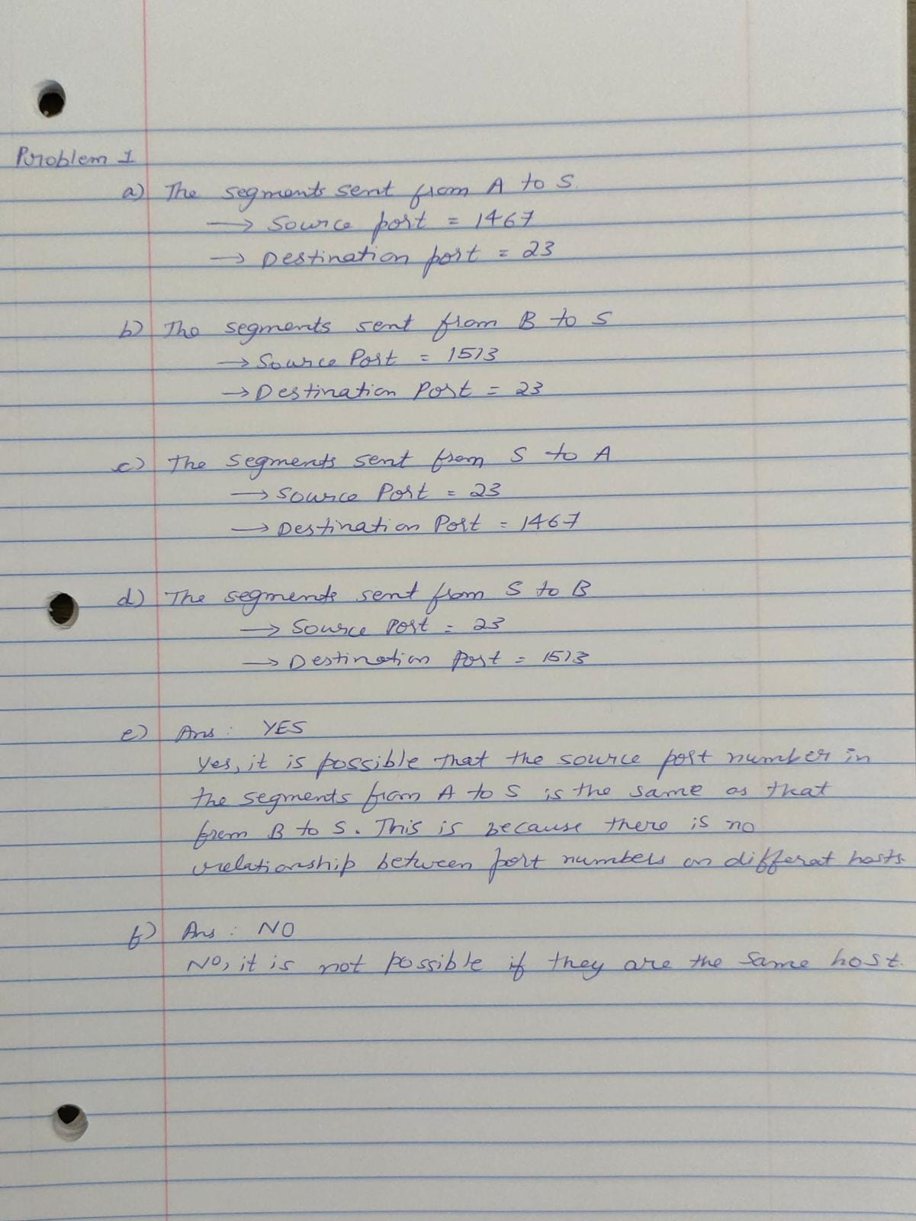

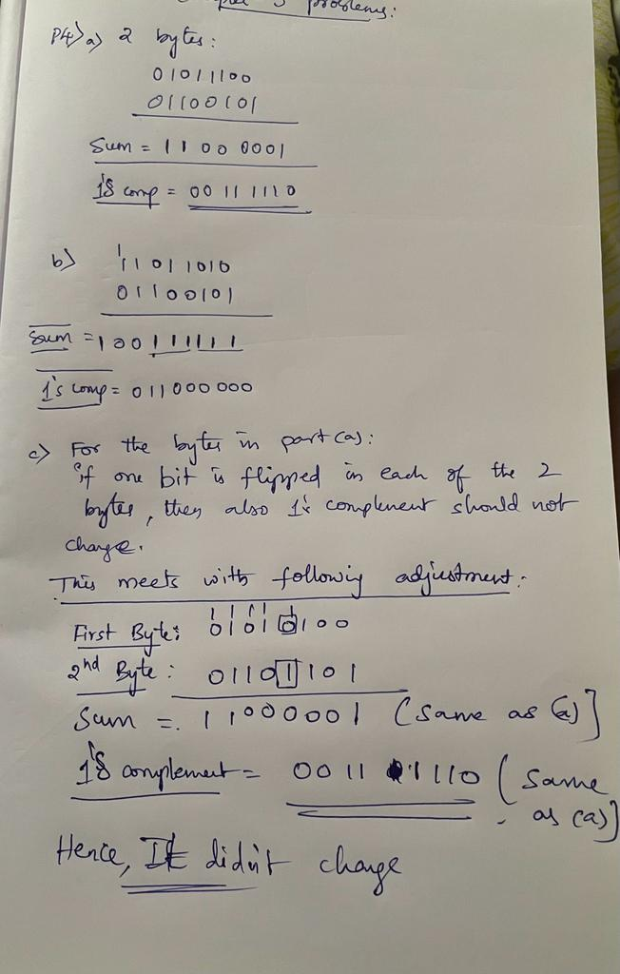

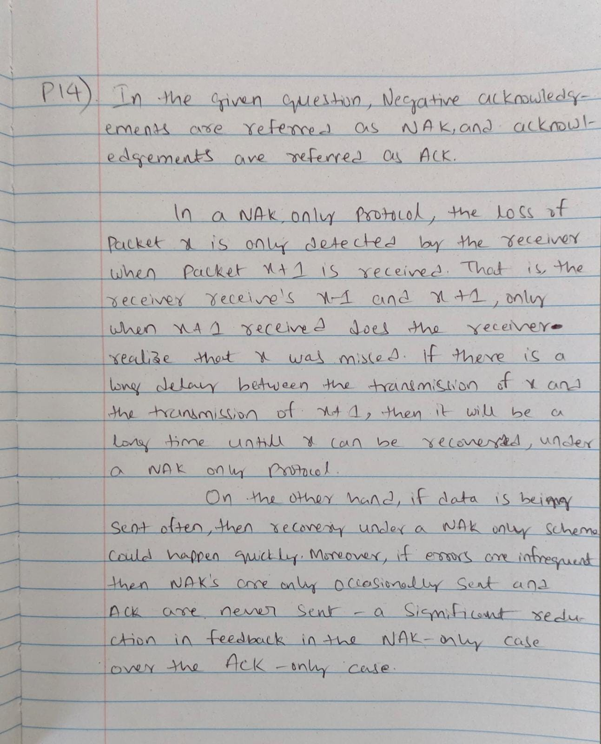

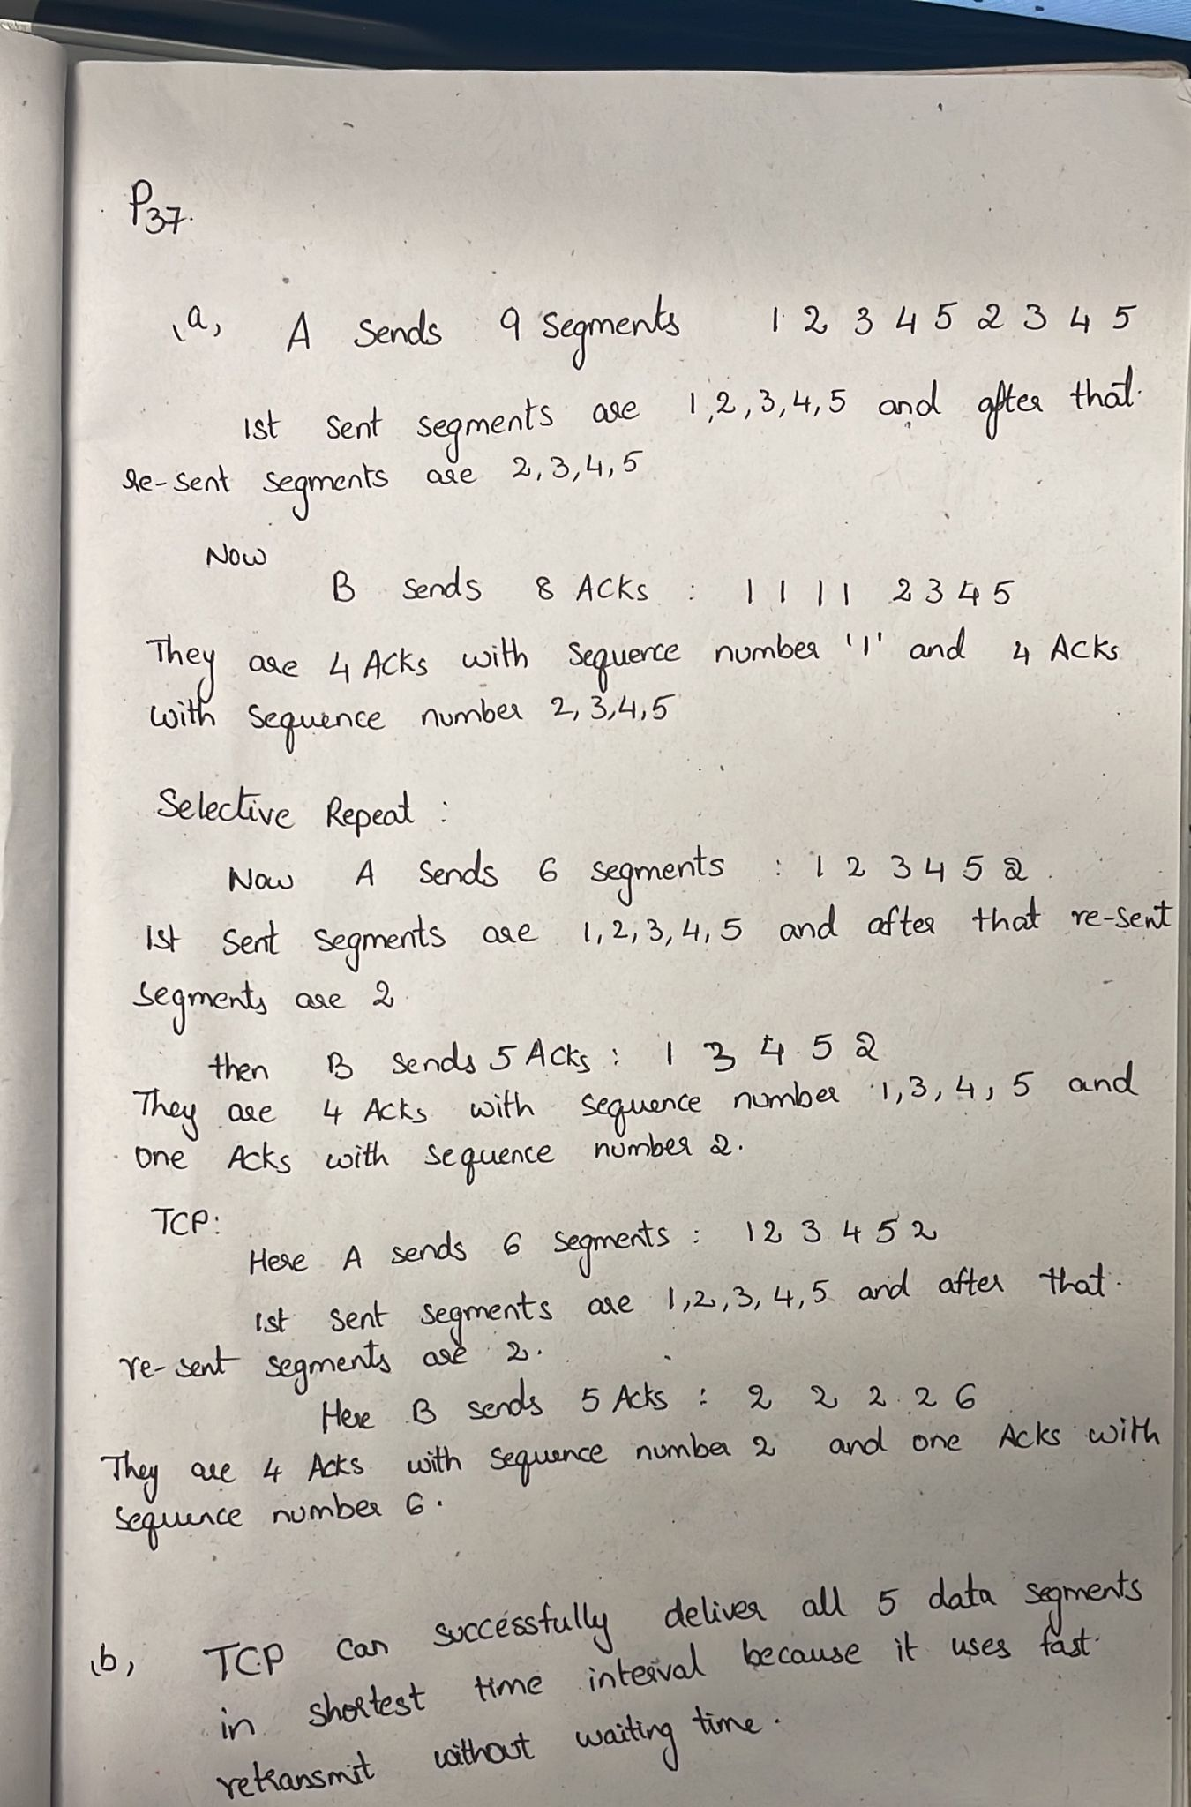

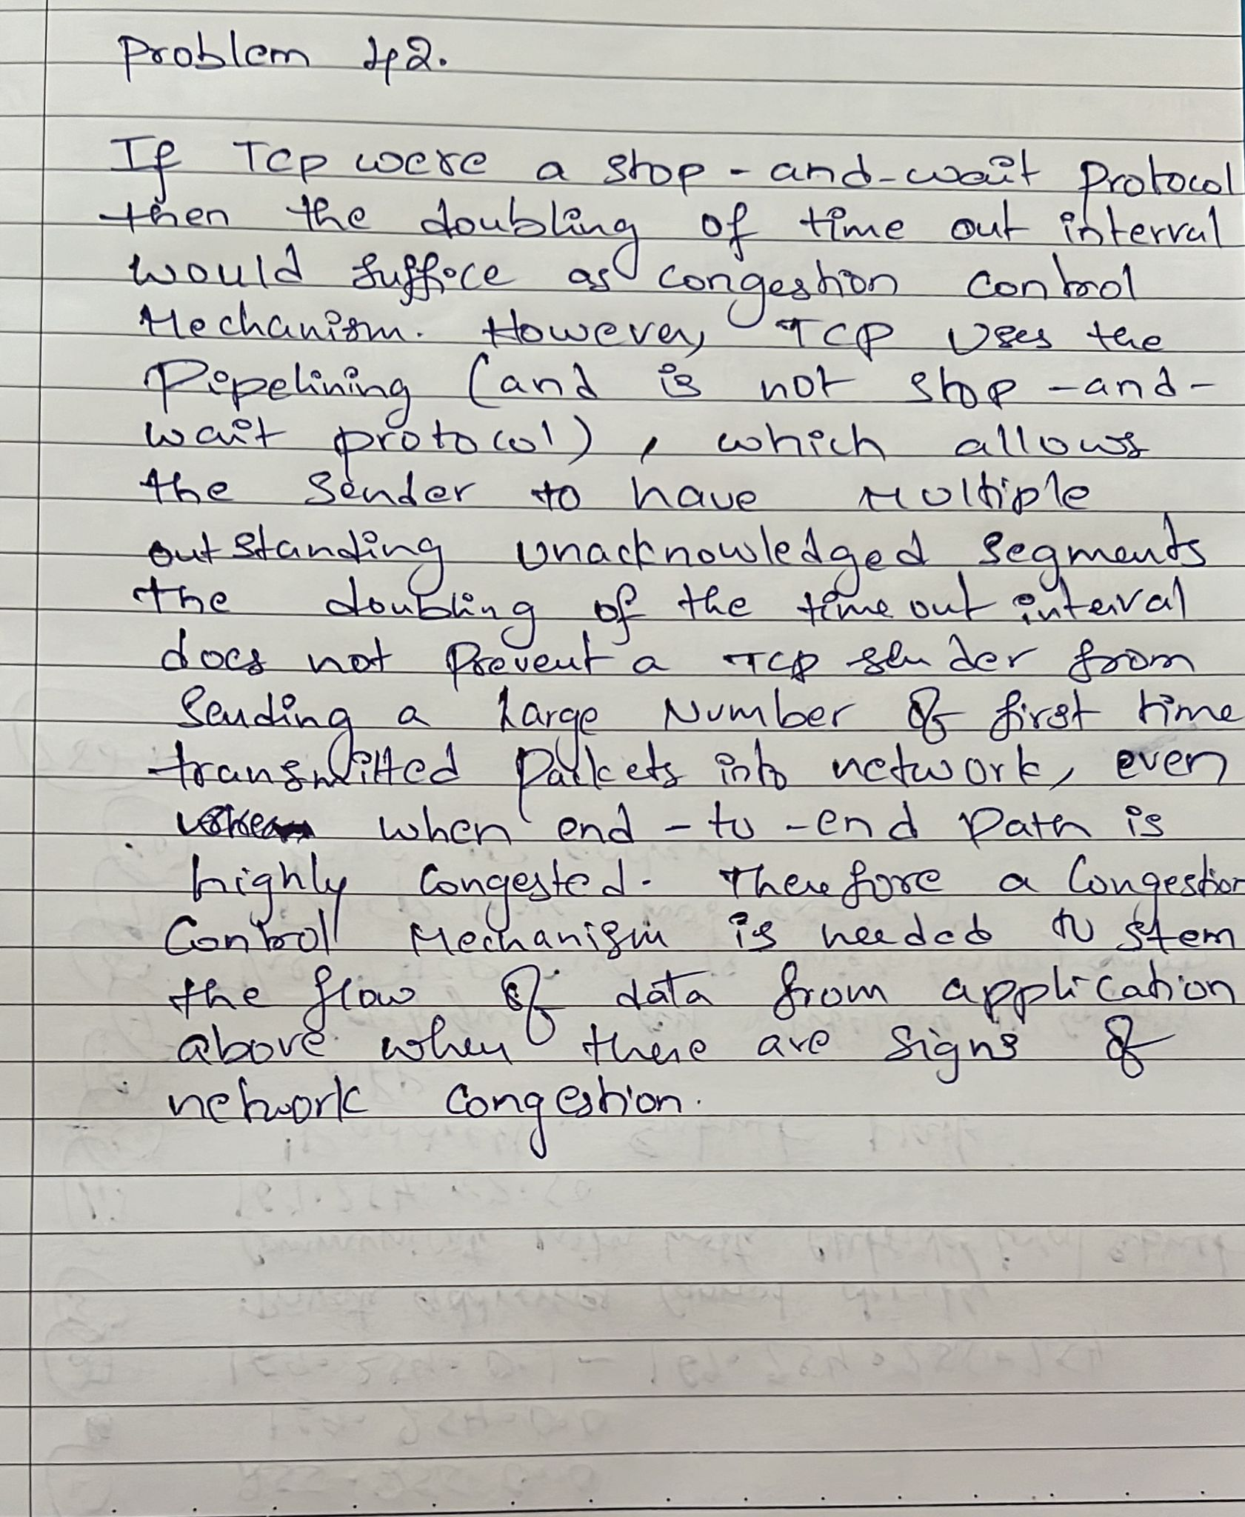

**Group 7:**

Ramakanth Ayalasomayajula

Akhilesh Reddy Pinnapureddy

Anvesh Raju Vishwaraju

Asritha Cherukuri

Lakshmi Pooja Devarapu